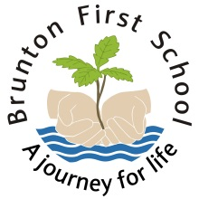
Free School Meals

From September 2014 all pupils in Reception, Year 1 and Year 2 will be able to receive a school meal at no cost to the parent/carer as recently announced by the government.

You must register for the school meals as the information you provide will be used to assess if your child should be on the pupil premium register. For each child on the pupil premium register the school receives £1300. This goes towards funding for music tuition, residential visits and teaching assistant support.

Please complete the registration form below and return it to school.

Children in Key Stage 2

If your child is in KS2 and you wish to apply for free school meals please fill in the registration form below and return it to school.

